Richik Mukherjee

Rickrmk2023@gmail.com

225

USER MANUAL DOCUMENT



Table of Contents

Introduction & Purpose 2

Structure & Organization 2

Dashboard Features & Components 4

Step-by-Step Navigation 4

Interactivity & User Functionalities 5

FAQs & Troubleshooting 5

Table of Figures

Figure 1: Profit vs Revenue Analysis 3

Figure 2: Customer Demographics Analysis 3

# **Introduction & Purpose**

The user manual is designed to help users understand the global market trends for retail products. It provides clarity about the difference between the revenue and profit margins for the products globally these are then categorized based on specific customer demographics. Through this user can better navigate and use the Sales Data from the dashboard to make quality decisions and learn about market trends.

The purpose also highlights users being able to optimize the dashboard by opting filters and slicers to get delegated information about the different product categories, countries and the revenue/profit for each type of product.

# **Structure & Organization**

The dashboard is divided into 2 major parts, it starts with establishing the difference between the revenue and profit of the 3 major product categories. There are different graphical representations supported with legends, filters and slicers to communicate specific information for the products.

1. The **first** dashboard also summarizes some of the major insights in the form of Cards which changes based on the preferred slicer setting chosen by the user. There are measures list as well for users to navigate through different outputs. This dashboard summarizes the major insights in the form of cards on top denoting the highest revenue product vs the lowest revenue product. The other insights include the total revenue, total profit and the total sales quantity which are further elaborated in the form different graphs highlighting demand patterns in countries with respect to the 3 product categories.
2. The **second** dashboard consists of the customer demographics analysis in the form of bar charts and line graphs. There is a filter setting as well for users to get insights for specific months. The bar charts are categorized further based on customer gender, this helps users get information about the product preference with reference to the gender. Further, line graphs summarize the sales quantity and the revenue secured based on the customer age to understand the pattern of consumption for products based on the age groups.

Please refer to **figures** **1** and **2** for better clarity.

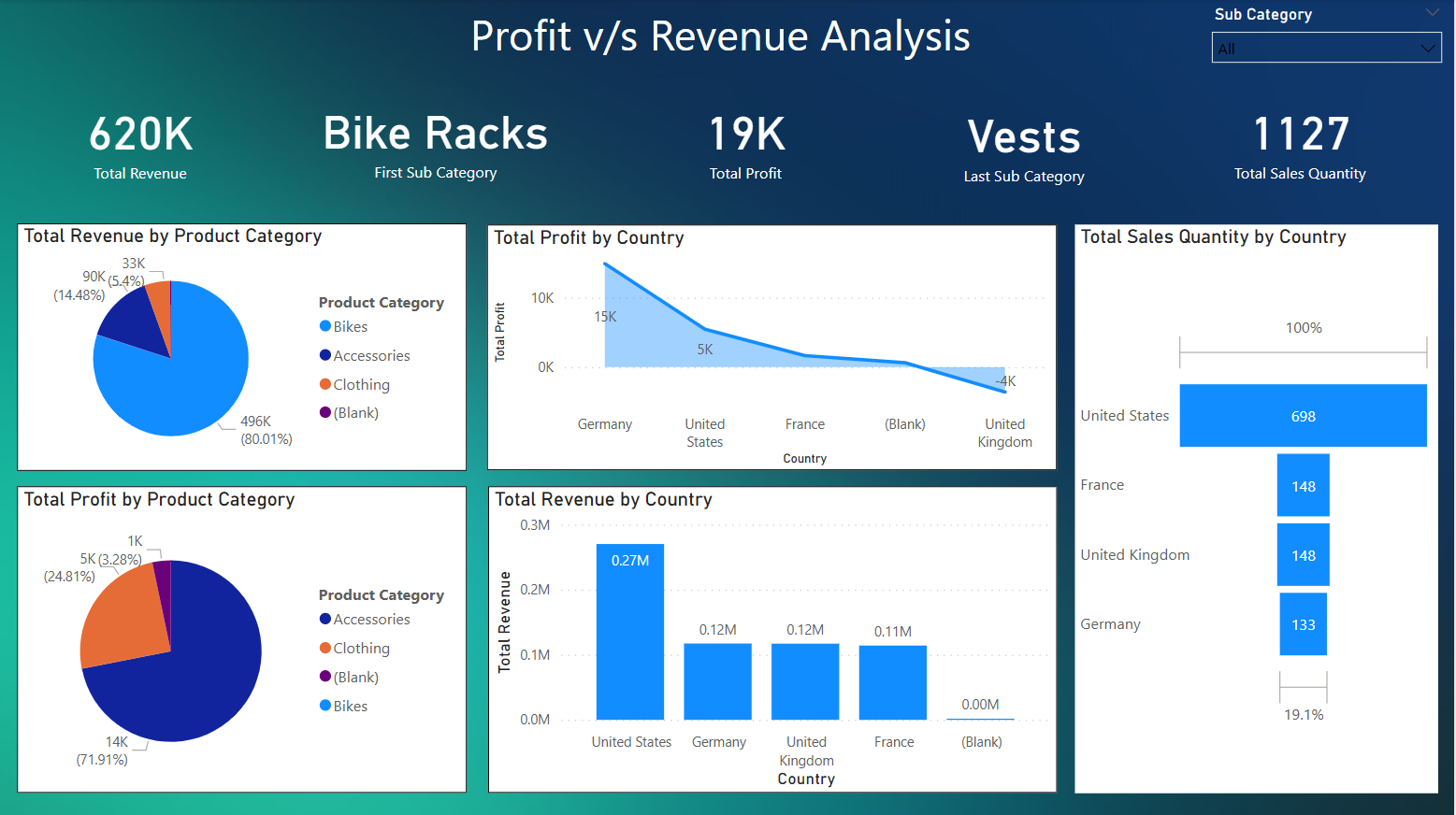

Figure 1: Profit vs Revenue Analysis

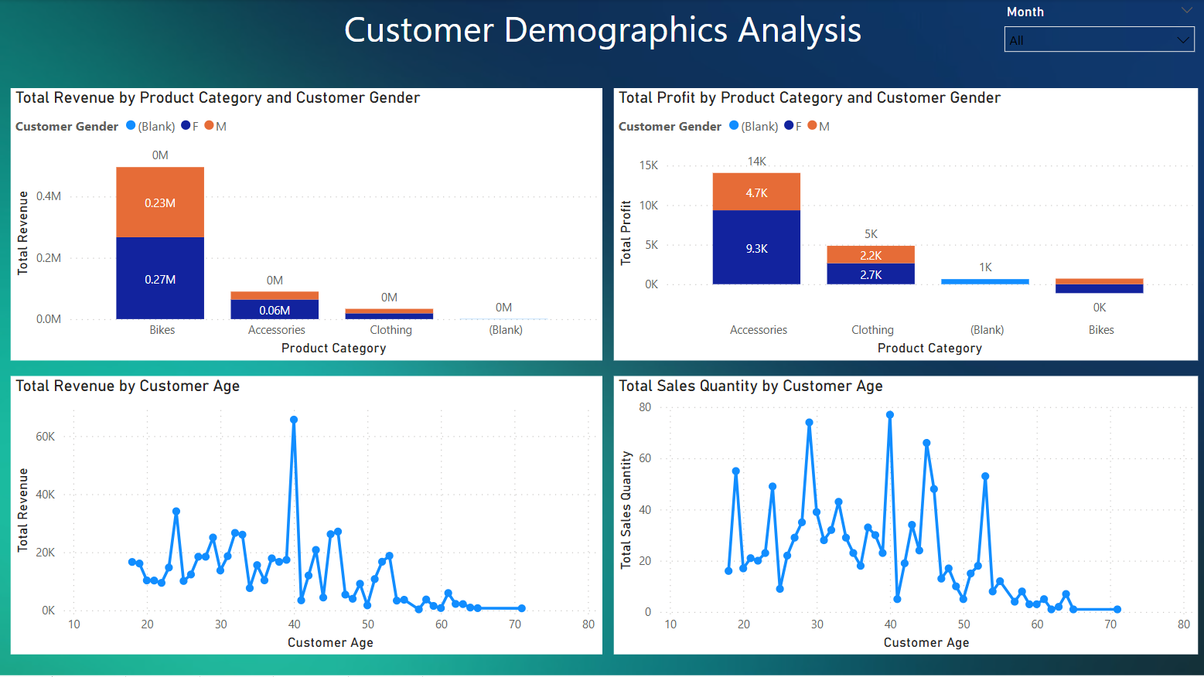

Figure 2: Customer Demographics Analysis

# **Dashboard Features & Components**

The dashboard features and components are listed below:

1. **Card:** The major insights of the dashboard are summarized in the form of cards showing the total revenue, highest sold sub product category, total profit, least sold sub product category and the total sales quantity. With these Cards’ users can get a crux of the whole analysis.
2. **Slicer:** Slicers are crucial for both dashboards, the first slicer has the Sub-Category for Products to help users get information about the specific items under the different categories. Next, the 2nd slicer has months to assist users in navigating through the data based on specific month.
3. **Pie Chart:** These representations show the shares of the 3 major product categories in total revenue and total profit. Pie Chart for this visualization suits perfectly as users can get a clear information about the exact percent of share for each type of product.
4. **Stacked Area Chart:** This chart is used in the first dashboard to show the total profit of products by country, with this user can understand the trend of profit in countries, the filter can be used in this case to navigate specifically with respect to sub categories in products.
5. **Line Graph:** These charts are used in the 2nd dashboard, it shows the comparison between the total revenue and total sales quantity with respect to the customer age, this shows the trend of sales and purchasing capability of different customer age groups.
6. **Funnel Chart:** The total sales quantity against the countries is summarized through this visualization, moreover users get the maximum and minimum percentiles as well to understand the purchasing power of the different countries and evaluate the trend of products and customer preferences.
7. **Stacked Column Chart:** The column chart is used in both the dashboards, the first one denotes the total revenue with respect to the countries to establish a comparison with the total profit. Further, the 2nd dashboard summarizes the total revenue and total profit with respect to product category and classified with the customer genders. This classification provides a comparison between the male and female customers and their purchase preferences.

# **Step-by-Step Navigation**

* **Opening the Dashboard**: The Power BI dashboard needs to accessed by downloading and installing the Microsoft Power BI Application either through the desktop version or logging in through the Power BI Web Service. Next, once the application is installed, the file will be saved as ‘Retail Sales Data’, once the file is opened the dashboards open displaying all slicers and charts along with the tables and data model (relationship-schema).
* **Exploring Main Sections**
  + Dashboard 1 Profit vs Revenue Analysis: The first dashboard consists of major insights of revenue, profit and sales quantity categorized by product category and countries. The top section of the dashboard has cards which summarize the major chunks of the whole analysis. Filters are also present for better navigation and getting specific insights.
  + Dashboard 2 Customer Demographics Analysis: This slide shows the analysis of total revenue, total profit and the Total Sales Quantity of products with respect to customer gender and customer age. The classifications are conducted in an inclusive manner to summarize the major insights in the form of column charts and line graphs. The ‘month’ filter is attached for users to navigate across the different periods and understand the trends of profit and sales quantity.
* **Utilizing Filters**: Slicers are attached in both dashboards, the first slide has a sub category filter for users to navigate through revenue/profits earned for specific items under the main product categories. Respectively, the 2nd slide has a slicer for month to show the trend of revenue and profits for the products with respect to customer preferences and age.
* Some additional features include the measures table that can be accessed by opening the data tab in the dashboard page, users can select different measures and replace it with the present ones to get different insights. The data model can also be accessed if users need insights about the type of relational schema used (snow-flake), this concludes a fuller understanding of the relationships between the different entities.

# **Interactivity & User Functionalities**

* **Drilling Down**: Users can gain better insights by hovering over charts or graphs and clicking on a specific value, this leads the users to a separate page or tabular view of the whole data.
* **Hover Actions**: Users can hover their cursor when viewing upon different values in a chart, for example, hovering the cursor over the column chart displaying the values for total revenue with respect to countries will show the exact value and the country.
* **Export/Download Options**: Users can simply go to the ‘File’ section and select the ‘export’ option to save the file in the form of **Power BI** or a **PDF** in their favorable storage location in their device. Moreover, there is also an option to simply ‘Save as’ and the file will be directly saved as Power BI file in their device location. Additionally, if users have signed in using their email, they can also publish the file in their Power BI workspace to view it online, this help users to get access portably.
* **Adjusting Timeframes**: The slicers for month and sub category can be adjusted in respective dashboards, users can select any option as per their preference to view insights accordingly in the dashboards.

# **FAQs & Troubleshooting**

List common questions users might have and their answers, such as:

* **I cannot see the data in the report, what to do?** - Sometimes Power BI may not have synced or refreshed the recent data, sometimes users may need to install the relevant dataset to support the Power BI operations. Sometimes, Power BI scans for the file, if it cannot sync automatically users should install the dataset to support the viewing, device compatibility can also be a reason.
* **The visuals are not loading. What should be done here?** – There can be internet connectivity issues, users are requested to ensure proper internet connection. Moreover, clearing browser cache can help if viewing online. Ensure a supported version of Chrome, Microsoft Edge or Firefox is installed. Users using desktop application can simply wait and refresh the dashboard to load the full data. If the issue persists, simply rebooting the application will fix the problem.
* **How to interact with the report is slicers or filters are not responsive?** – Sometimes slicers or filters fail to respond, in this case refreshing the report and double checking if filters are used correctly will solve the issue.

**THANK YOU**